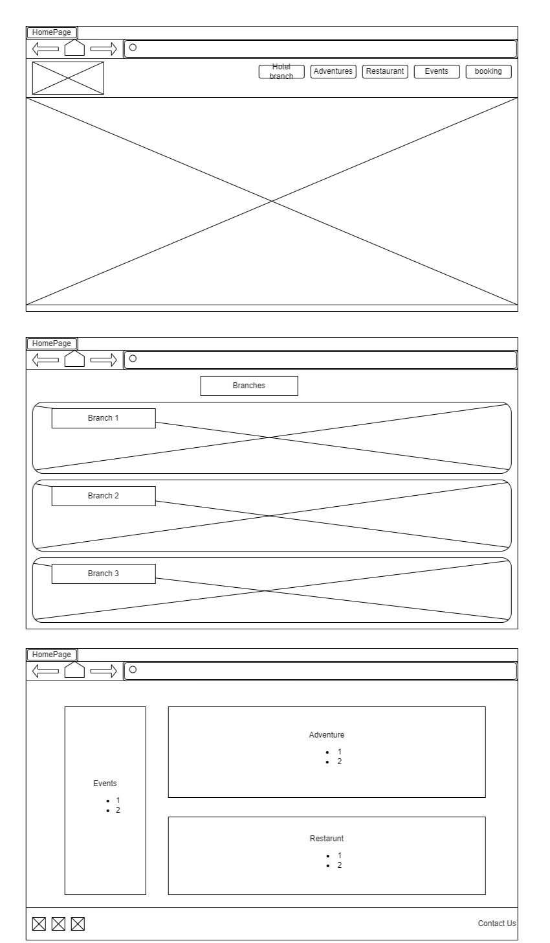**Desktop view**

Home P

Hotel Branches

Adventures

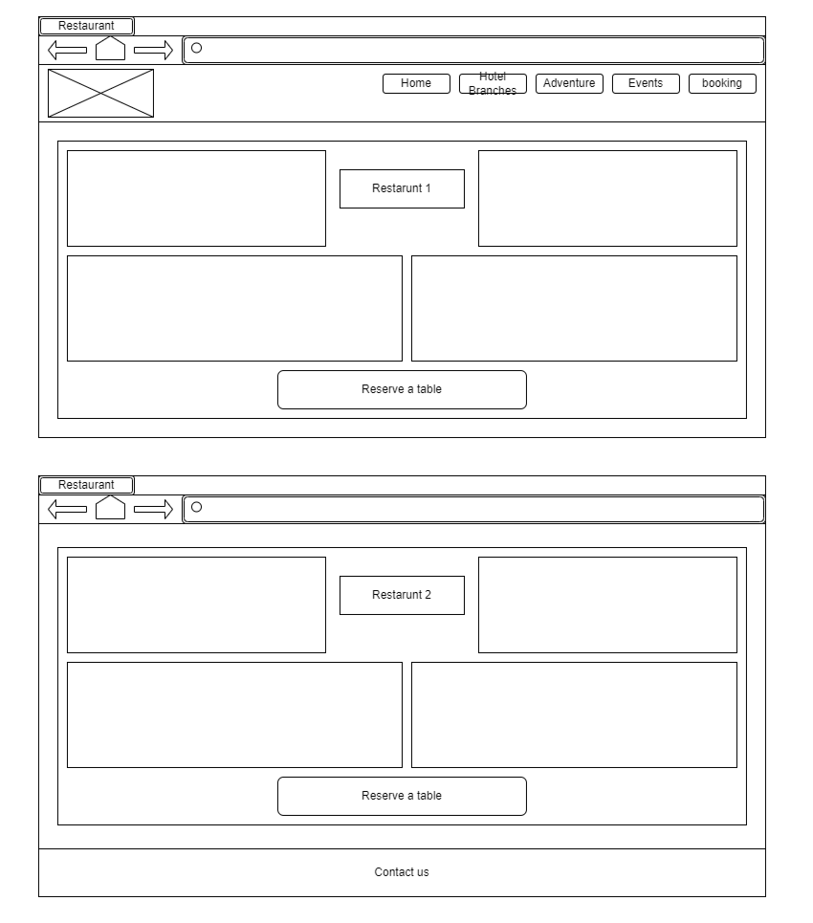Restaurants

Events

Booking

